GEMLAB | AUTOMATION PROJECT

Automated Lead Discovery & TeleCRM Integration
A practical, non-technical project guide with workflow, tools, libraries and implementation steps.
PROJECT GOAL
Reduce manual searching by finding relevant business leads from permitted sources, cleaning the records, and sending suitable leads to TeleCRM for the sales team.

1. How the system works

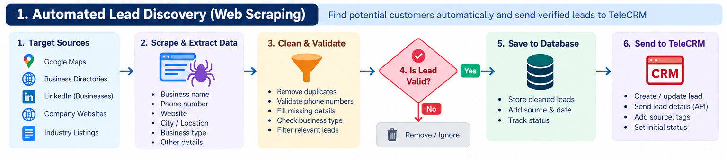

In simple terms: choose who to find → collect business details from approved sources → remove duplicates → review lead quality → send to TeleCRM → track sales outcomes.

2. What information can be collected?
Business name | Name of the shop or company.
Public business phone | A number explicitly listed for business contact, where permitted.
Website / source URL | Where the record was found, for review and audit.
City / region | Helps the sales team prioritize relevant areas.
Business category | For example, jewellery retailer, gemstone dealer or potential partner.
Lead status | New, reviewed, qualified, contacted, interested or not suitable.
Permission / opt-out status | Record the basis for contact and suppress future outreach when required.

3. Recommended tools and libraries
Choose the smallest stack that solves the problem. Start with one approved source and a test TeleCRM workflow before scaling.
Tool / library | Purpose | When to use it
Python | Main automation language | Runs collection, cleaning, scoring and sync tasks.
n8n | Workflow automation | Connects scheduled jobs, approvals, alerts and TeleCRM actions.
Requests or HTTPX | Call web/API endpoints | Use for documented APIs and permitted HTTP requests.
Beautiful Soup 4 | Read HTML pages | Use only where site terms permit page parsing; not for bypassing controls.
Scrapy | Structured crawling | For larger, permitted crawling projects with rate limits and source rules.
pandas | Clean and organize records | Normalize columns, filter incomplete records and export CSV/XLSX.
phonenumbers | Phone-format checks | Checks number format; does not prove ownership or consent.
Pydantic | Validate record schema | Ensures required fields and expected data types.
SQLAlchemy + PostgreSQL | Store and deduplicate leads | Useful for audit history, source tracking and production storage.
RapidFuzz | Possible duplicate matching | Flags similar business names/addresses for review.
FastAPI | Optional backend/API | Useful if the workflow needs a custom service or web dashboard.
TeleCRM API / workflow | CRM destination | Use only actions documented and enabled for GemLab's account.
Metabase (optional) | Reporting dashboard | Reports on lead counts, quality, follow-up and conversion.

4. Suggested technical stack
- Starter MVP: Python + Requests/HTTPX + pandas + Pydantic + one permitted source + CSV review + TeleCRM workflow.
- Workflow-first option: n8n for scheduling and routing, with a small Python script for cleaning or extraction.
- Production option: FastAPI + PostgreSQL/SQLAlchemy + scheduled worker + source-specific connectors + TeleCRM integration + monitoring.
- Do not add a vector database or LLM just to collect leads. Add AI only if it materially improves business-category matching, lead summaries or prioritization.

5. Lead scoring and review
A simple score helps the sales team focus on relevant leads. Start with transparent rules and allow a person to review uncertain records.
- Target match: business category fits GemLab's chosen customer or partner type.
- Location match: city or region is within the agreed sales area.
- Data quality: business name and source are present; contact field is correctly formatted.
- Freshness: source is recent enough for the business use case.
- Review flag: mark uncertain, duplicate or restricted records instead of automatically contacting them.

6. TeleCRM integration flow
- Confirm TeleCRM API access, authentication and permitted create/update actions.
- Map the fields to TeleCRM's actual schema; do not assume endpoint names or payloads.
- Search for an existing lead before creating a new one to reduce duplicates.
- Save source URL, date collected, category, city, review status and contact-permission status where supported.
- Use a test pipeline first; log success/failure and retry temporary errors safely.
- Let the sales team review and approve leads before outreach during the pilot.

7. Compliance, privacy and safe collection
- Use official APIs, licensed providers or public pages whose terms permit the intended collection.
- Respect robots.txt where applicable, terms of service, rate limits and access restrictions.
- Do not bypass logins, CAPTCHAs, paywalls or technical controls.
- Prefer business contact details published for business enquiries; avoid harvesting private personal details.
- Public visibility does not automatically mean marketing consent. Confirm the lawful basis and channel rules before outreach.
- Honor opt-outs and suppression lists; keep only the data needed for the business purpose.
- Protect API keys and customer data; restrict access and define retention periods.

8. Implementation plan
Phase 1 — Define | Choose lead type, target cities, permitted sources and required fields.
Phase 2 — Source test | Test one source and confirm its terms, data quality and collection method.
Phase 3 — Clean | Normalize data, deduplicate, validate fields and add source tracking.
Phase 4 — Review | Score sample leads and have sales staff approve quality.
Phase 5 — TeleCRM | Map fields and connect a supported API/workflow in a test pipeline.
Phase 6 — Pilot | Run on a small batch, measure errors and lead quality, then scale gradually.

9. Success metrics
- Relevant leads collected per day/week.
- Percentage of records with complete, valid business fields.
- Duplicate rate and invalid-contact rate.
- Percentage of leads accepted by the sales team.
- Time saved compared with manual searching.
- Contact-to-reply, qualified-lead and conversion rates, measured only where tracking is permitted.

10. Decisions needed from GemLab
- Which leads are the priority: jewellery shops, gemstone retailers, franchise partners, or individual buyers?
- Which cities or regions should be covered first?
- Which data sources are approved for collection?
- Which fields should be mandatory in TeleCRM?
- Who reviews lead quality and approves outreach?
- Which TeleCRM actions and reporting fields are available in the current account?
RECOMMENDED FIRST VERSION
Start with one permitted business directory or licensed data source, collect a small sample, clean and review it, then push approved leads into a TeleCRM test workflow. Expand only after source permission, data quality and CRM integration are confirmed.

